# 9/24 Meeting

Date: 9/17/25

Time: 11:00am-12:00pm CDT

Attendees: Juliette Reeder, Jack Hicks, Forrest Tuschhoff, Dr. Chuck Bunting, Dr. Pavithrakrishnan Radhakrishnan

**Field Testing at Richmond Hills Friday 9/26**

**CDR next Friday 8/3**

**Spectrum Analyzer:**

* FieldFox from Endeavor - Dr. Bunting will need to contact Brian Norton

**EZNEC:**

* Include plots for antenna at different heights/angles
* 200Ω with 4:1 BALUN

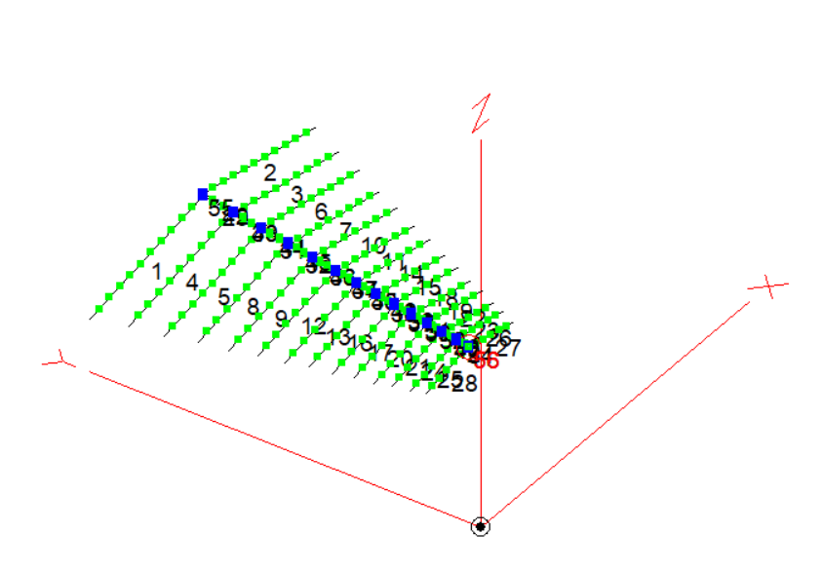

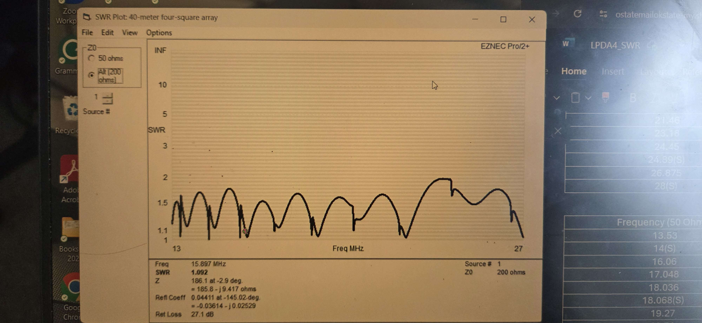

**Materials:**

* Rhon tower / flag pole (reach out to Derek)
* 18 AWG copper wire
* Nylon ropes
* Stakes
* Insulators for wires
* Coil winders (wire management) (3D print)
* 4:1 Balun

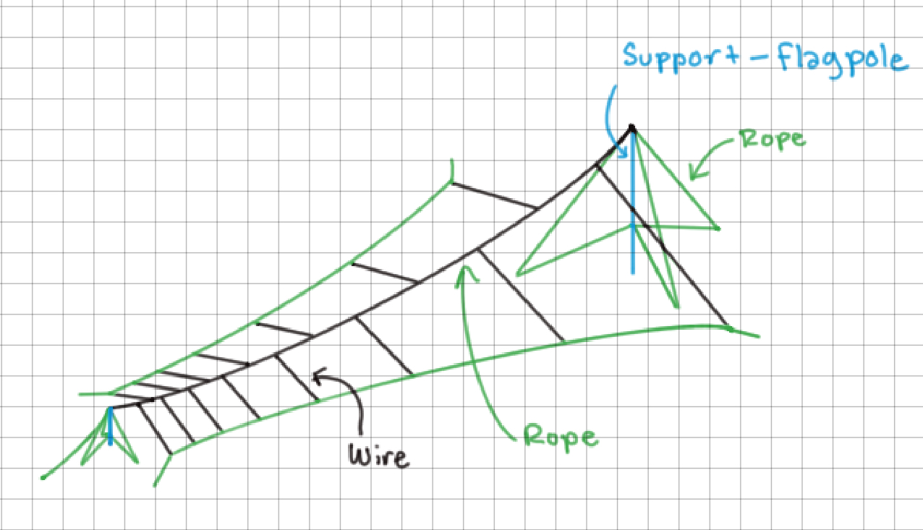

**Testing Plan:**Test to determine 3dB bandwidth of LPDA antenna:

* Two matching LPDA antennas
* DUT rotated with pivot point based on phase
* Field LPDA kept fixed

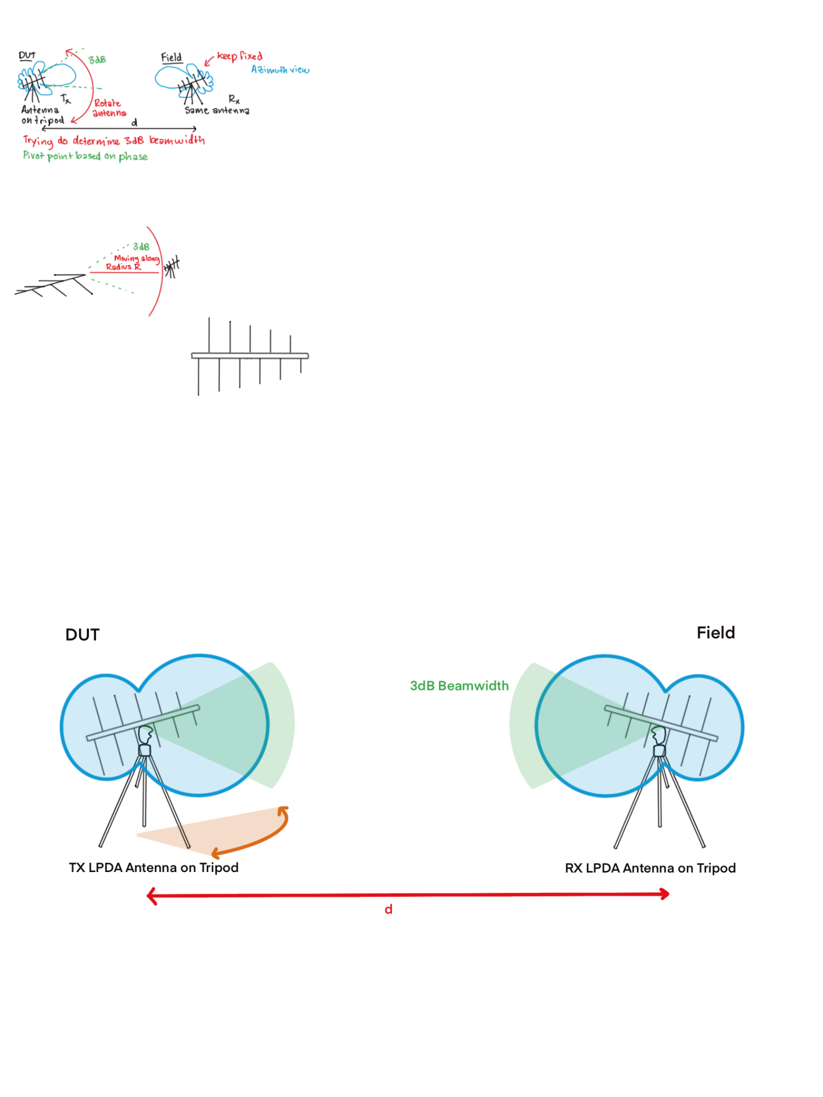

Modified test to determine 3dB bandwidth of LPDA antenna:

* Two matching LPDA antennas
* DUT kept fixed
* Field LPDA moved along radius r

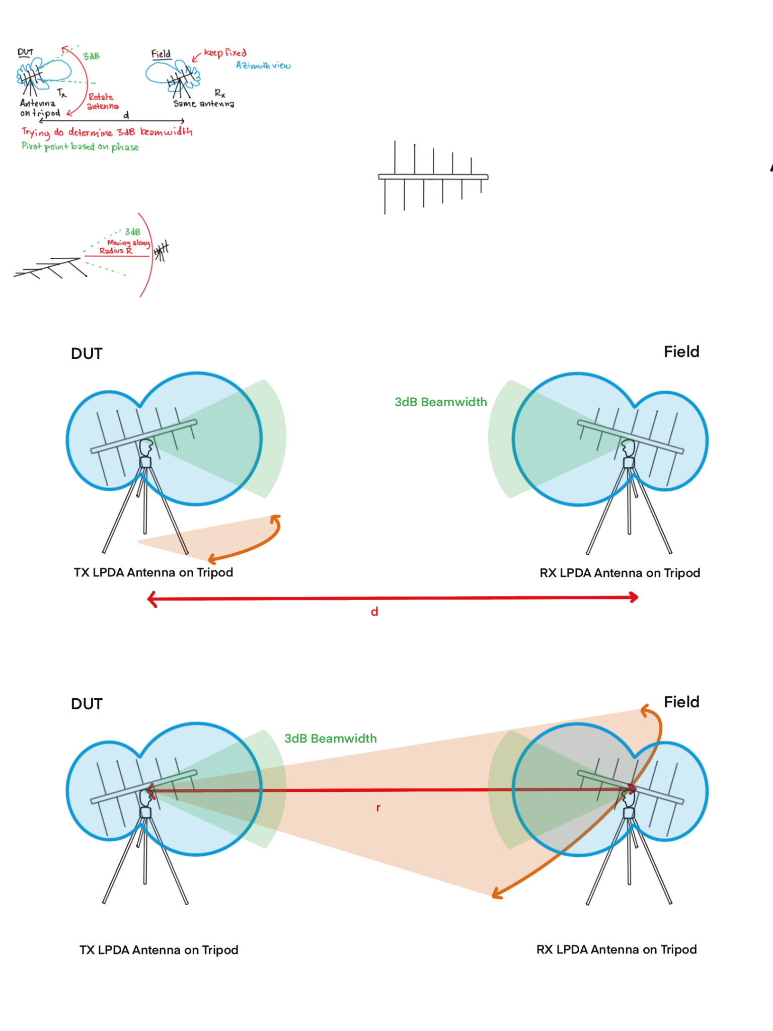

Modified test to determine 3dB bandwidth and distance of designed LPDA antenna:

* Small antenna from previous test in
* DUT kept fixed
* Field LPDA moved along radius r

